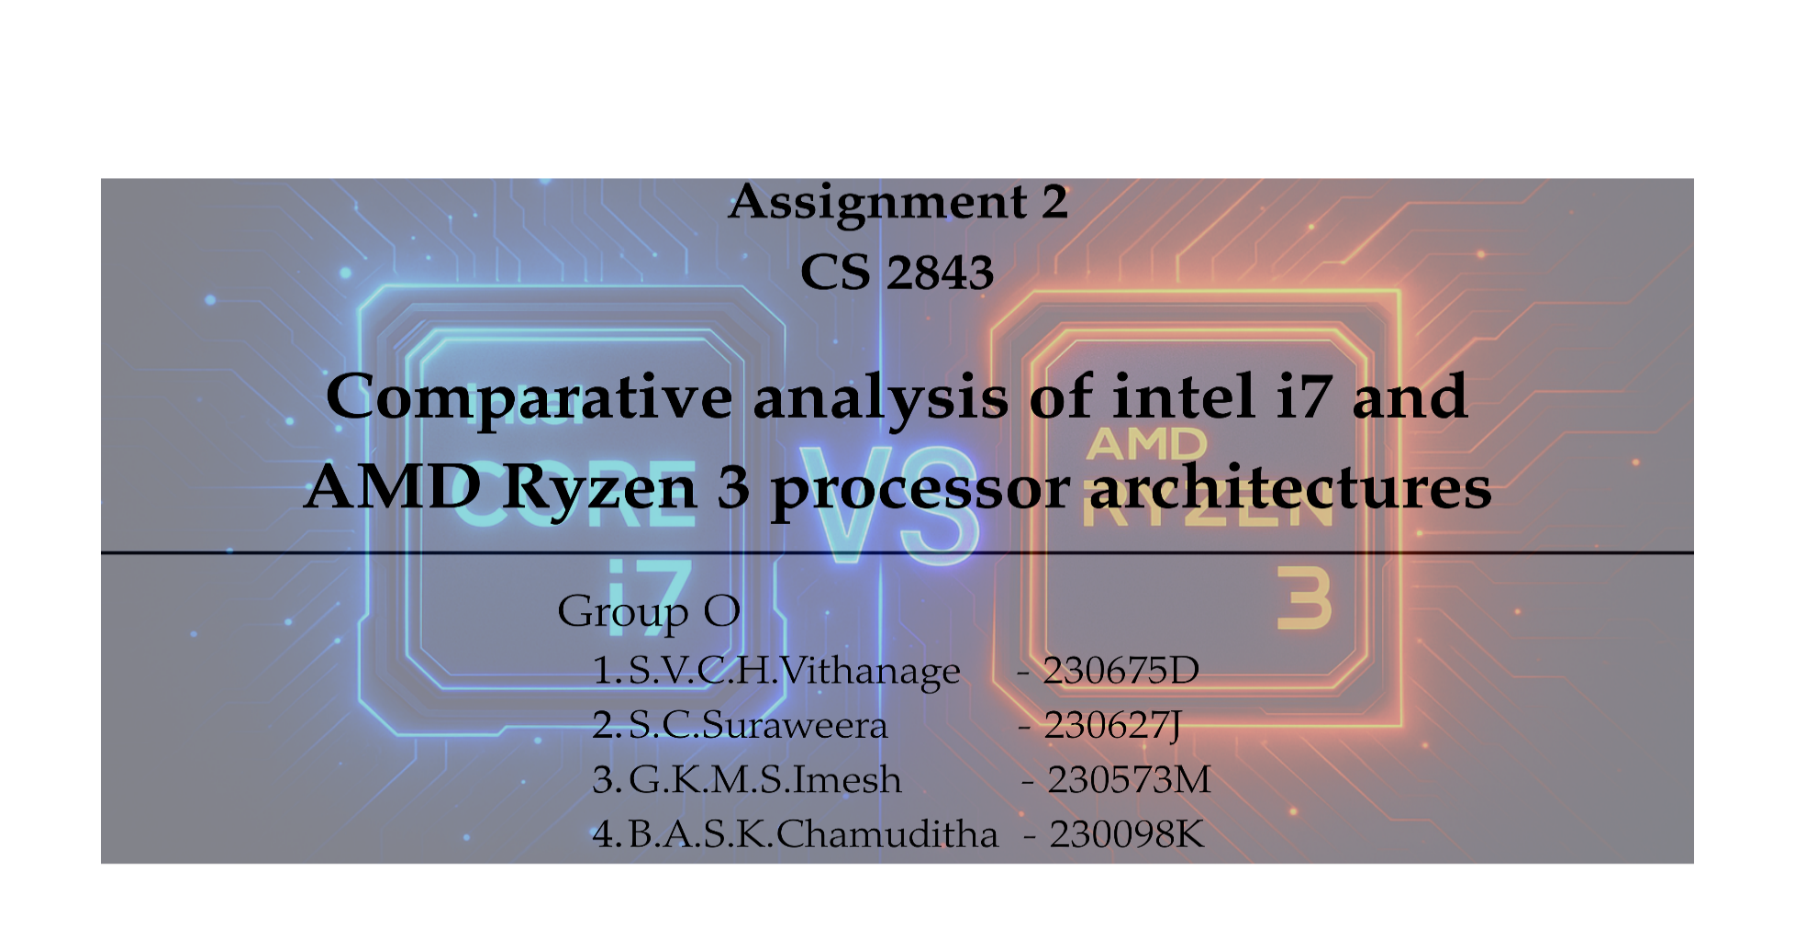

**1.Introduction:** This technical analysis compares two distinct processor architectures, Intel's i7 series and AMD's Ryzen 3 series highlighting their relative strengths and weaknesses across multiple dimensions of processor design.

**2.Processor Architecture:**

1. **Microarchitecture**

* Intel i7 consists of microarchitectures like **Nehalem, Sandy Bridge, Ivy Bridge**, and **Skylake**, each with performance advancements.
* AMD Ryzen 3 is based on microarchitectures like **Zen2**, **Zen3** which are energy efficient and scalable.

1. **Cache Hierarchy**

* Intel i7 processors consist of multilevel caches such as L1, L2, and L3 which enable faster retrieval of data.
* AMD Ryzen 3 has an equivalent cache structure.

1. **Core Design**

* Generally, Intel i7 uses four physical cores for parallel processing, and hyperthreading is used for doubling the number of threads that the processor can handle.
* AMD Ryzen 3 uses 4 physical cores and uses simultaneous multithreading to double the number of threads to 8.

1. **Instruction set**

* The Intel i7 processor supports x86-64 instruction sets and supports instruction sets such as SSE2, SSE3, and SSE4 to optimize performance.
* AMD Ryzen3 uses x86-64 instruction sets and supports instruction sets such as SSE4.2, AVX2, and FMA3.

**Conclusion:**

* Intel i7 is superior in microarchitecture as it has a long lineage of advancements.
* The cash hierarchy is similar for both processors.
* The threading capability is similar for both, as both processors have 4 cores and 8 threads.
* AMD Ryzen 3 is superior to instruction sets as it supports more advanced instruction sets like AVX2 and FMA3.

**3.Memory Architecture Comparison**

|  |  |  |  |  |
| --- | --- | --- | --- | --- |
| **Feature** | **AMD Ryzen 3** | **Intel core i7** | **Superior** | **Reason** |
| **Memory type** | **DDR5** | **DDR5, DDR4** | **-** | **Both offers higher speeds, great bandwidth and lower power consumption.** |
| **Maximum memory Speed** | **\*DDR5 – 5200 MT/s**  **\*DDR5 – 3600 MT/s** | **\*DDR5 – 5600 MT/s**  **\*DDR4-3200 MT/s** | **Intel core i7** | **Intel core i7 officially supports DDR5 at a higher speed(5600MT/s). And also, it offers the flexibility of using either DDR5 or DDR4.** |
| **Number of channels** | **Dual channel** | **Dual channel** | **-** | **Dual channel memory increases the bandwidth which allows faster loading and smoother overall system responsiveness.** |
| **Cache Hierarchy** | **L1: 64 KB/core**  **L2: 1 MB/core**  **L3: 8 MB shared** | **L1: 80 KB/core**  **L2: 2 MB/core(Pcore), 4 MB/module (E-core)**  **L3: 33 MB shared** | **Intel core i7** | **Larger L2, L3 caches significantly improve the performance by reducing latency.** |
| **Memory Capacity** | **Up to 64 GB or 128 GB** | **Up to 64 GB or 128 GB** | **-** | **Both support up to 64 GB or 128 GB memory configurations depending on the motherboard.** |

**Conclusion:  
●** AMD Ryzen 3 offers better thermal efficiency due to its 7nm process and lower TDP, making it easier to cool. Intel i7 delivers higher performance but generates more heat, requiring stronger cooling solutions. Intel’s hybrid architecture improves efficiency for light tasks, but it still produces more heat.

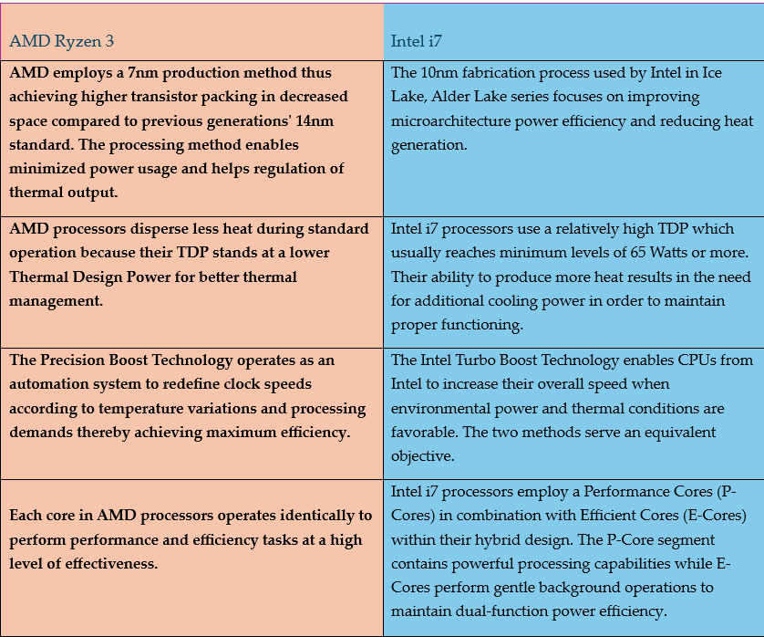**4.Thermal management:**

**Conclusion:** The superior choice depends largely on the target workload. Intel i7 generally excelling in professional applications requiring strong single-threaded performance, while AMD Ryzen 3 offers advantages in terms of efficiency and graphics capabilities.

**References**

* <https://www.amd.com/en/products/processors/desktops/ryzen/8000-series/amd-ryzen-3-8300g.html>
* <https://www.techpowerup.com/review/intel-core-i7-14700k/2.html>
* <https://www.intel.com/content/www/us/en/products/sku/236783/intel-core-i7-processor-14700k-33m-cache-up-to-5-60-ghz/specifications.html>
* [**https://www.egenuma.com/ict-api/amds-ryzen-3-architecture**](https://www.egenuma.com/ict-api/amds-ryzen-3-architecture)
* [**https://www.intel.com/content/www/us/en/products/details/processors/core/i7.html**](https://www.intel.com/content/www/us/en/products/details/processors/core/i7.html)
* **AMD Official Ryzen Processor Documentation – AMD Ryzen Processors**
* **Intel 12th and 13th Gen Architecture Overview – Intel Core Processors**
* **Anand Tech Processor Reviews – Anand Tech CPU Reviews**